1.0 Python Download and Installation

First, ensure that you have Python installed on your system by running “python3 --version” or “py --version” in your command line based on your OS. If Python is installed, you will see an output message such as “Python 3.13.1”. If it is not installed, proceed with the following.

Visit the official Python website at <https://www.python.org/> and click on “Downloads” in the banner.

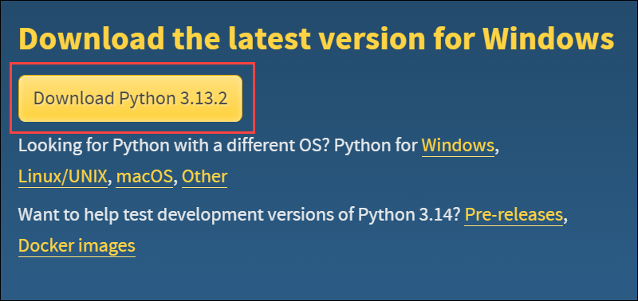

Click on the “Download” button to download the latest version of Python.

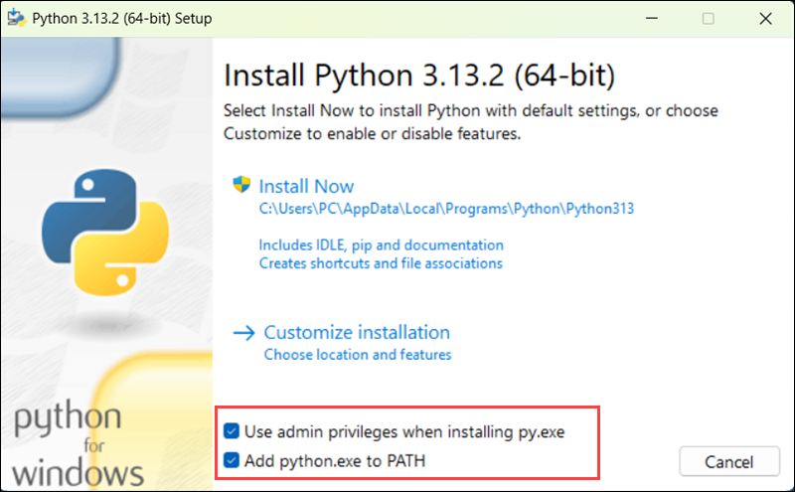

After the download is complete, double-click the Python installation file from the folder it was saved in. Ticking the box for the admin privileges allows you to change the installation folder for Python. The second box makes Python accessible from anywhere in your command prompt. It is recommended to tick both checkboxes. Press “Install Now” to start the installation. If asked to allow this app to make changes to your device, click “Yes”.

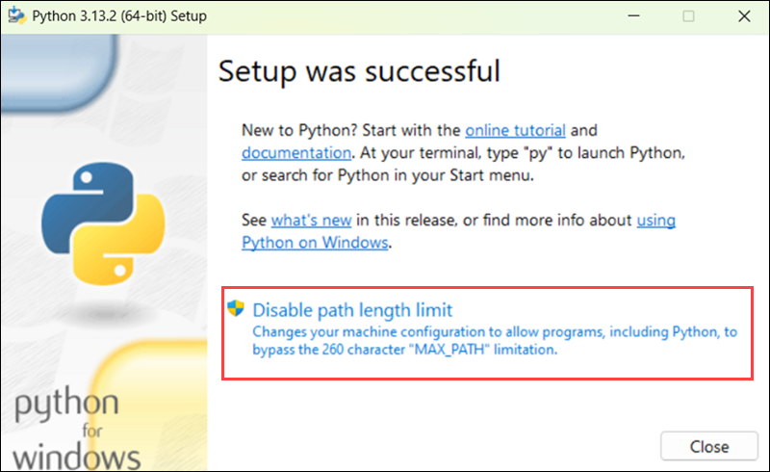

Click “Disable path length limit” to ensure that Python can use paths more than 260 characters in length. If asked to allow this app to make changes to your device, click “Yes”. Click “Close” to exit the installer.

2.0 Pycharm Installation

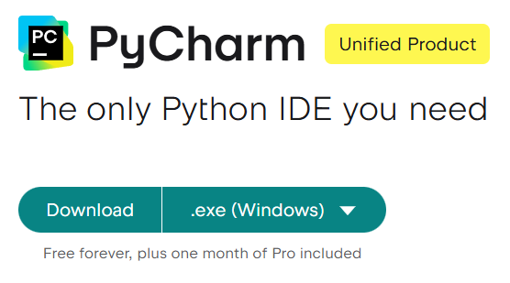

Visit the Jetbrains official website at <https://www.jetbrains.com/pycharm/download/?section=windows> and click on “Download”.

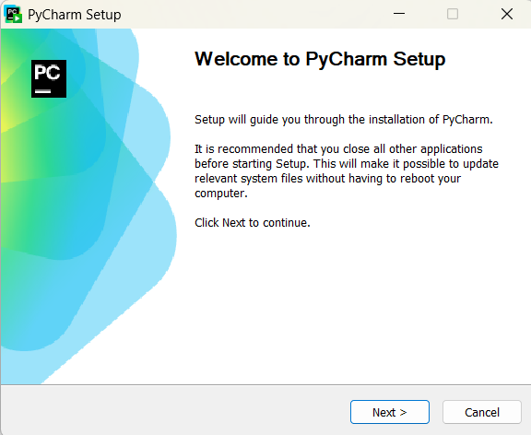

After the download is complete, double-click the Pycharm installation file from the folder it was saved in. If asked to allow this app to make changes to your device, click “Yes”. Click “Next”.

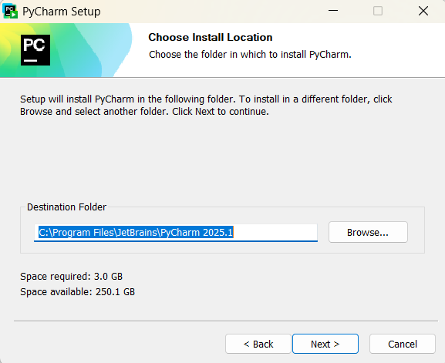

Select the destination folder and click “Next”. Configure your installation by checking the boxes that you want to apply. Click “Install”.

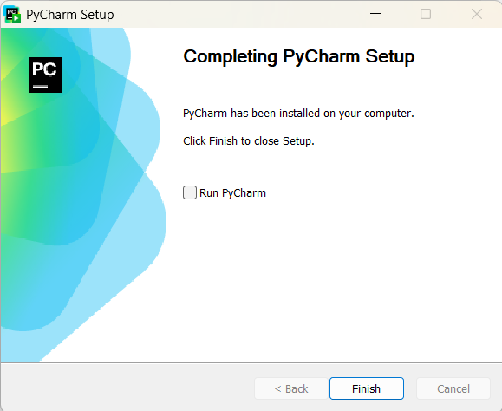

Click “Finish” to complete the installation.

3.0 Microsoft SQL Server Management Studio (SSMS) Download and Installation

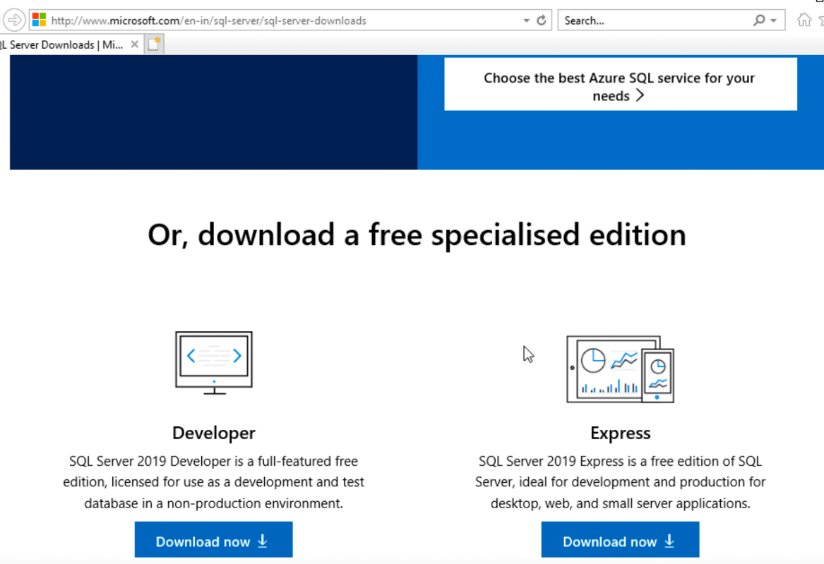

Visit <https://www.microsoft.com/en-us/sql-server/sql-server-downloads> and click on the “Download now” button for the Express version.

Once downloaded, double-click the SSMS installation file from the folder it was saved in. If asked to allow this app to make changes to your device, click “Yes”. If it says that your computer must be restarted before the setup can continue, click restart and relaunch the installation file.

Click “Install”. If asked to allow this app to make changes to your device, click “Yes”. Once the installation is complete, click “Restart” if asked to restart.

4.0 Download ODBC Driver for SQL Server

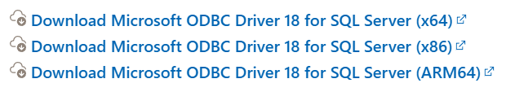

Select the appropriate version for your device.

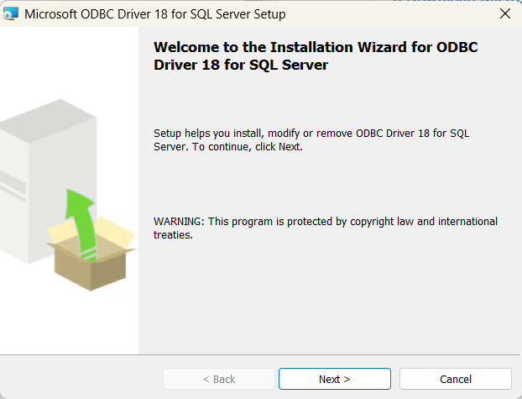

Click “Next”.

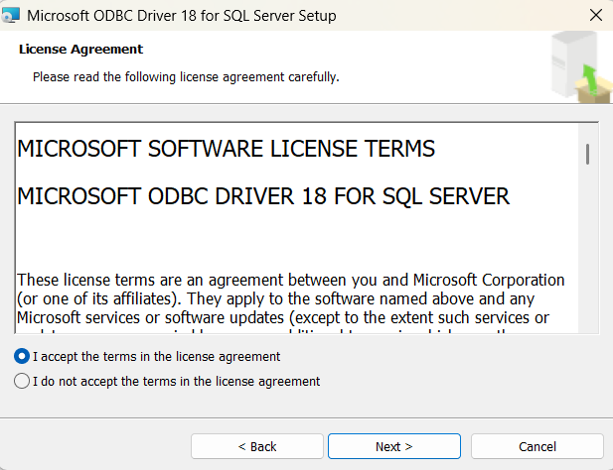

Read and agree to the terms in the license agreement. Click “Next”.

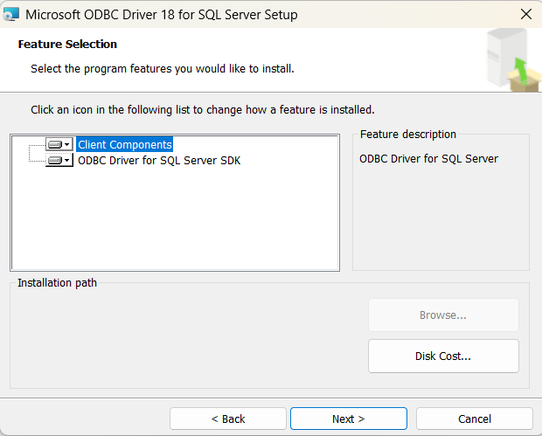

Click “Next”.

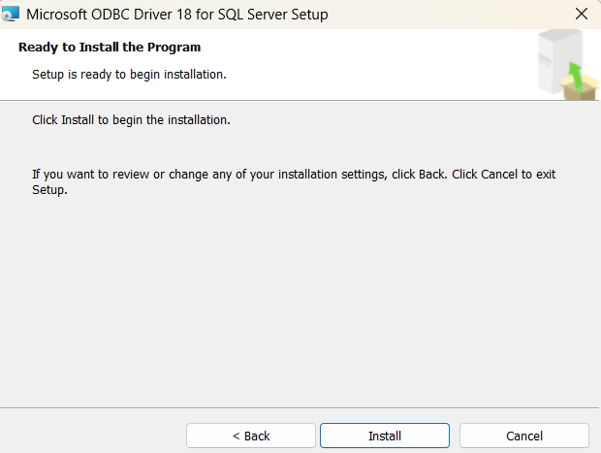

Click “Back” if changes need to be made. Otherwise, click “Install”. If asked to allow this app to make changes to your device, click “Yes”.

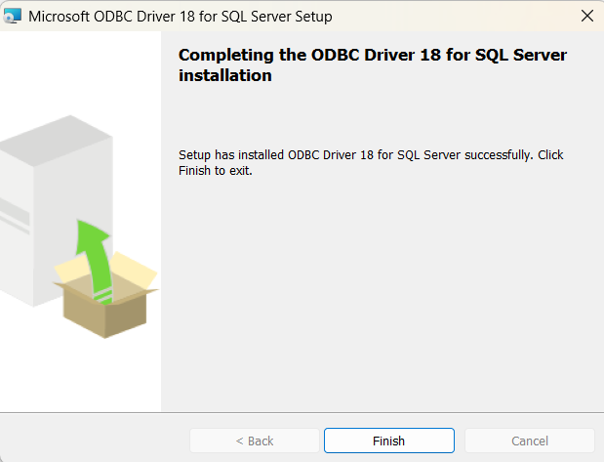

Click “Finish” to complete the installation.

5.0 Create SQL Server

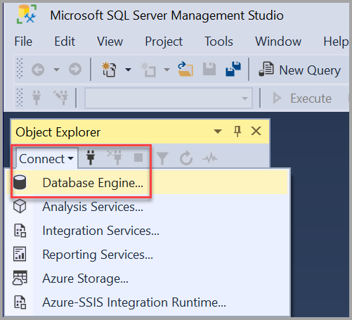

The first time SSMS is run, the Connect to Server window opens. If it doesn’t, it can be manually opened by clicking “Connect”, then clicking “Database Engine”.

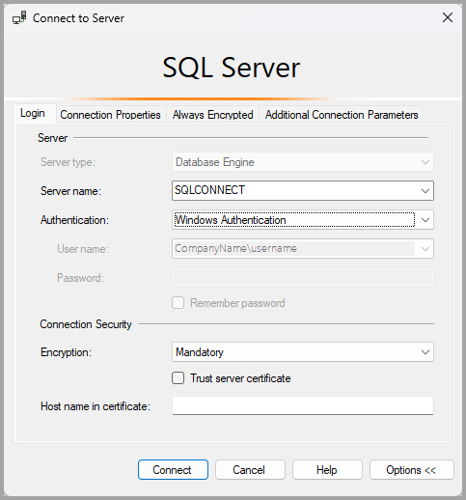

For the server type, select “Database Engine”. For the server name, use your PC name. For authentication, select “Windows Authentication”. To change the read-only username, sign into your device as a different user. After all fields have been completed, click “Connect”.

6.0 Import Database

Right-click on “Databases” and select “Import Data-tier Application”

Click “Next”.

Click “Browse” and select the Capstones.bacpac file from your downloads. Click “Next”.

Click “Finish”.

After the database has been successfully imported, click “Close”.

7.0 Pip Download and Installation

Check if pip is already installed by running “pip --version” in your command line.

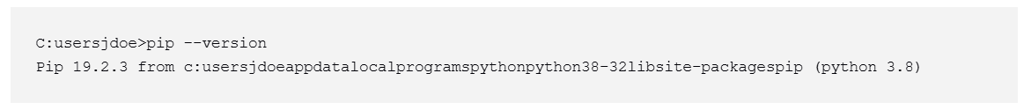

The above figure shows the sample output you would see if pip is installed. If pip is not installed, proceed with the following.

Run “py -m ensurepip --upgrade” in your command line to install pip. Run the “pip --version” command again to ensure that pip has been installed. If pip is still not installed, proceed with the following.

Download the official pip installer using the command “curl [https://bootstrap.pypa.io/get-pip.py -o get-pip.py](https://bootstrap.pypa.io/get-pip.py%20-o%20get-pip.py)”. Follow up with the command “py get-pip.py”.

8.0 Install Packages

Open your terminal in Pycharm. The first method is to enter the command “pip install -e .” If that doesn’t work, the second command that you can enter is “pip install -r requirements.txt”. Otherwise, proceed to the following steps.

Run the following commands in your terminal:

* “pip install pygame”
* “pip install pyodbc”
* “pip install pillow”
* “pip install pyqt5”
* “pip install matplotlib”
* “pip install numpy”

Additionally, you can run the command “pip list” to ensure that all packages have been installed correctly. You should see the above package names listed in the output.